REPORT

|  |  |
| --- | --- |
| TEAM ID | PNT2022TMID43481 |
| PROJECT TITLE | REAL-TIME RIVER WATER QUALITY MONITORING AND CONTROL SYSTEM |
| TEAM LEADER | VAISHNAVI R |
| TEAM MEMBER 1 | VARUNKUMAR N |
| TEAM MEMBER 2 | THAILA UMA A |
| TEAM MEMBER 3 | ROSHINI S |
| TEAM MEMBER 4 | NARMATHA S |

**INTRODUCTION**

**PROJECT OVERVIEW**

**River Water quality monitoring System** Water is one of the major compounds that profoundly influence ecosystem. But, nowadays it is been exploited heavily due to rapid industrialization, human waste and random use of pesticides and chemical fertilizers in agriculture, which leads to water contamination. Thus, a water monitoring system is necessary to observe the water quality in a large area such as lake, river, and aquaculture. As per the current world situation, Internet of Things (IoT) and remote sensing techniques are used in heterogeneous areas of research for supervising, congregate and analyzing data from the remote locations. In this paper, the suggested system is a minimal price real time water quality monitoring system in IoT environment. This system comprise of numerous sensors for assessing the physical and chemical parameter. The factors of water that can be assessed using these sensors are pH, turbidity, conductivity, dissolved oxygen. Using this system the real time quality of water bodies can be determined and the data uploaded over the Internet are analysed .

**PURPOSE**

Data collected over a period of time will show trends, for example identifying increasing concentrations of nitrogen pollution in a river or an inland waterway. The total data will then help to identify key water quality parameters. Collecting, interpreting and using data is essential for the development of a sound and effective water quality strategy. The absence of real-time data will however hamper the development of strategies and limit the impact on pollution control. Using digital systems and programs for data collection and management is a solution to this challenge.

**LITERATURE SURVEY**

**EXISTING PROBLEM**

Due to population growth, urbanization ,and climatic change ,competition for water resources is expected to increase, with a particular impact on agriculture, river water. Water will be suitableness to potable water monitoring compound spillage identification done rivers, remote estimation for swimming pools. It holds self-sufficient hubs that unite with the cloud to ongoing water control .The River water needed to be treated before it is used in agriculture feilds,hence the parameters affecting the quality of river-water need to be analysed and to be used for water treatement purpose.

**REFERENCE**

**1) IoT Based Real-time River Water Quality Monitoring System**

Mohammad Salah UddinChowdury, Talha BinEmran,

**Science Direct – 2018**

This paper proposes a sensor-based water quality monitoring system. The main components of Wireless Sensor Network (WSN) include a microcontroller for processing the system, communication system for inter and intra node communication and several sensors. Real-time data access can be done by using remote monitoring and Internet of Things (IoT) technology.

**2) Review of Water Quality Monitoring using Internet of Things (IoT)**

Mr. A. P. Roger Rozario, R. Surya

**IEEE, 2019**

The quality of the water must be monitored in real-time to ensure its safety and supply. Monitoring water in traditional ways takes longer, which can take up to from 24 to 96 hours to identify contaminants in water supplies, which are more time taking. This project aims at developing a water quality monitoring system using sensors and IoT (Internet of Things). The water quality parameters like temperature, pH, and turbidity are measures using sensors and the water quality index is determined. The measured values from the sensors will be processed using a microcontroller, and alert message will be sent to the user via an android application developed using MIT app inventor in case of any abnormalities.

**3) A Development and Implementation of Water Quality Assessment Monitoring (WQAM) System using the Internet of Things (IoT) in Water Environment**

Muhammad Farhan Johan, S. Abdullah, A. Zanal Saurabh S. Soman, Hamidreza Zareipour , Om Malik

**JEVA , 23 November 2021** This paper presents the development and implementation of Water Quality Assessment and Monitoring (WQAM) system. The system development used Wi-Fi enabled microcontroller to connect with the IoT environment and store the data in the IoT cloud server. The microcontroller used is Arduino UNO that interacts with three types of sensor probes which are pH, turbidity and temperature probe. All the data measurements is transferred using a Wi-Fi module which is ESP8266. The IoT cloud used to utilize the data frame is Thing Speak. This system was implemented on Bandar Pereda Lake and Deraa River in Pulao Pinang with two systems implemented at each location. The sensors were placed on the water surface for more accurate measurements. This system continuously measures the readings of pH, turbidity dan temperature on the lake/river for every 1 hour. Twenty readings were taken for every 1 hour within the first 20 minutes with 1 minute interval and the readings were stored in the IoT cloud server.

**4) IoT-based System for Real-time Water Pollution Monitoring of Rivers**

Mohammad Ariful Islam Khan; Mohammad Akidul Hoque; Sabbir Ahmed

**IEEE September 2021**

The research proposes a system to remotely monitor the water quality of a river so that the authorities can gather better insights about the condition of that particular river and predict the critical future phenomena. Consequently, they will be able to take auspicious steps in order to protect the rivers and save the environment. The proposed framework can observe the real-time value of pH, conductivity, turbidity, temperature and flow of the water by utilizing various sensors. Furthermore, through our device, effective predictions about imminent floods can be made. Thus, authorities can commence early warning for floods and ensure prompt evacuation. Thus, our technique can significantly minimize the casualties caused by this disaster. In this context, real-time feeds are obtained through Internet of Things (IoT). For wireless data transmission Message Queuing Telemetry Transport (MQTT) is used.

**5) Design and Implementation of Real Time Approach for The Monitoring of Water Quality Parameters**

Siti Aishah Binti Makhtar; Norhafizah Binti Burham; Anees Bt Abdul Aziz

**IEEE - June 2022**

Access to safe drinking water is essential to nurturing human life on earth. Polluted air and unsanitary water can cause health problems. Unhygienic water can cause stomach and health-related problems.

A specific range of water quality parameters, mainly temperature, pH, total dissolved solids (TDS) and turbidity, can degrade the growth of this bacteria. This presented paperwork is to develop a smart water quality monitoring system using four sensors and an IoT platform to help determine water quality. It is to analyse the parameters of water samples such as tap water, co way water, river water, pond water, and lake water whether these water samples are in the threshold range for drinking or not. The device is initially used to measure pH, turbidity, total dissolved solids (TDS) and temperature, and then sent the information to the microcontroller Arduino Uno.

**PROBLEM STATEMENT DEFINITION**

**IDEATION AND PROPOSED SOLUTION**

**EMPATHY MAP CANVAS**

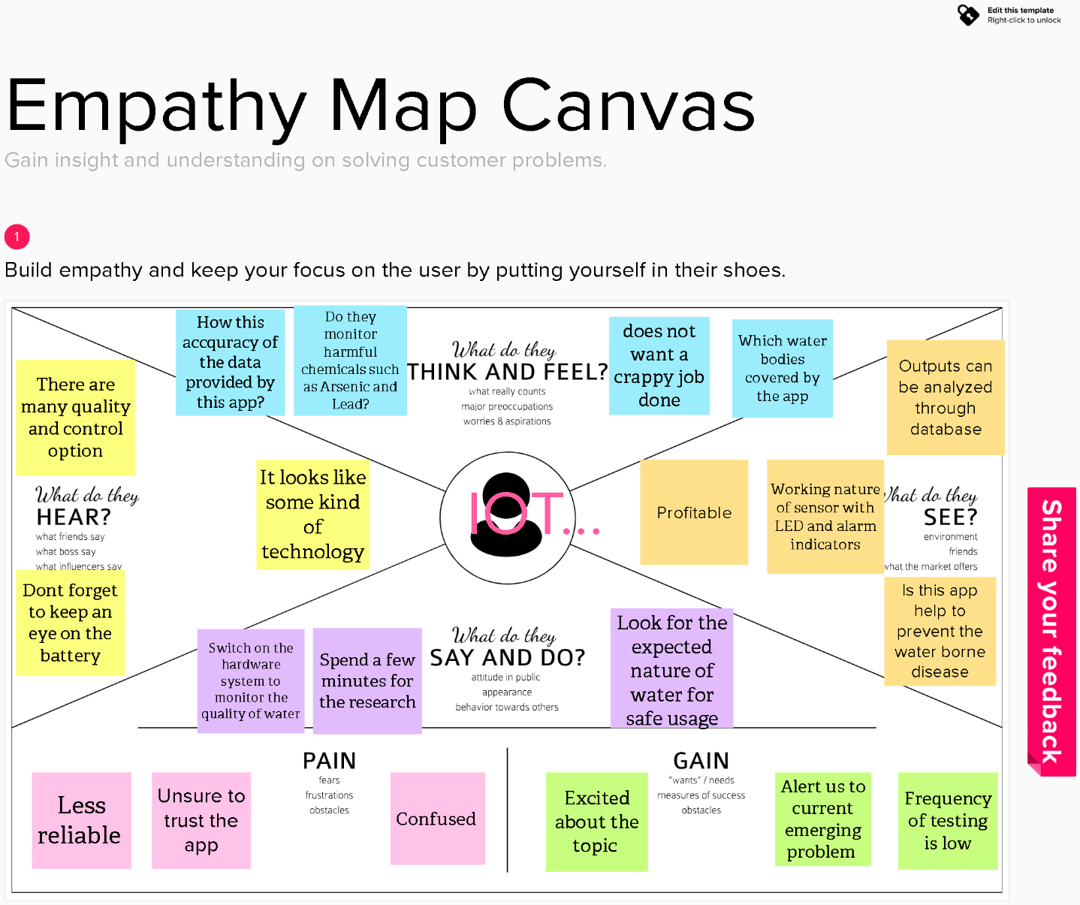

**IDEATION AND BRAINSTROMING**

Brainstorming provides a free and open environment that encourages everyone within a team to participate in the creative thinking process that leads to problem solving. Prioritizing volume over value, out-of-the-box ideas are welcome and built upon, and all participants are encouraged to collaborate, helping each other develop a rich amount of creative solutions. Use this template in your own brainstorming sessions so your team can unleash their imagination and start shaping concepts even if you're not sitting in the same room.

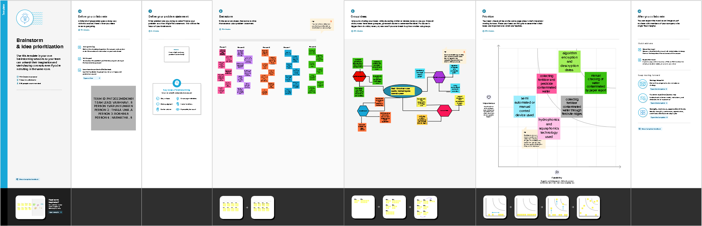

**PROPOSED SOLUTION**

|  |  |  |
| --- | --- | --- |
| **S.No.** | **Parameter** | **Description** |
| 1. | Problem Statement (Problem to be solved) | Massive growth of algae called eutrophication leads to pollution(monitoring and controlling the quality of river water) |
| 2. | Idea / Solution description | Detecting the dust particles , PH level of water, Dissolved oxygen and temperature to be monitored and altering the authorities if water quality is not good. |
| 3. | Novelty / Uniqueness | River water quality can be monitored by web application.  Quality parameter will track continuously with standard measurements. |
| 4. | Social Impact / Customer Satisfaction | Localities will not get suffered by poor quality of water by alerting them when the water quality is not good. |
| 5. | Business Model (Revenue Model) | Water quality monitoring system by aeron systems for industrial water treatment plant, river bodies, aqua forming ,digital loggers. |
| 6. | Scalability of the Solution | Measuring of real time values and continuous monitoring helps in maintaining the quality of water. |

**PROBLEM SOLUTION FIT**

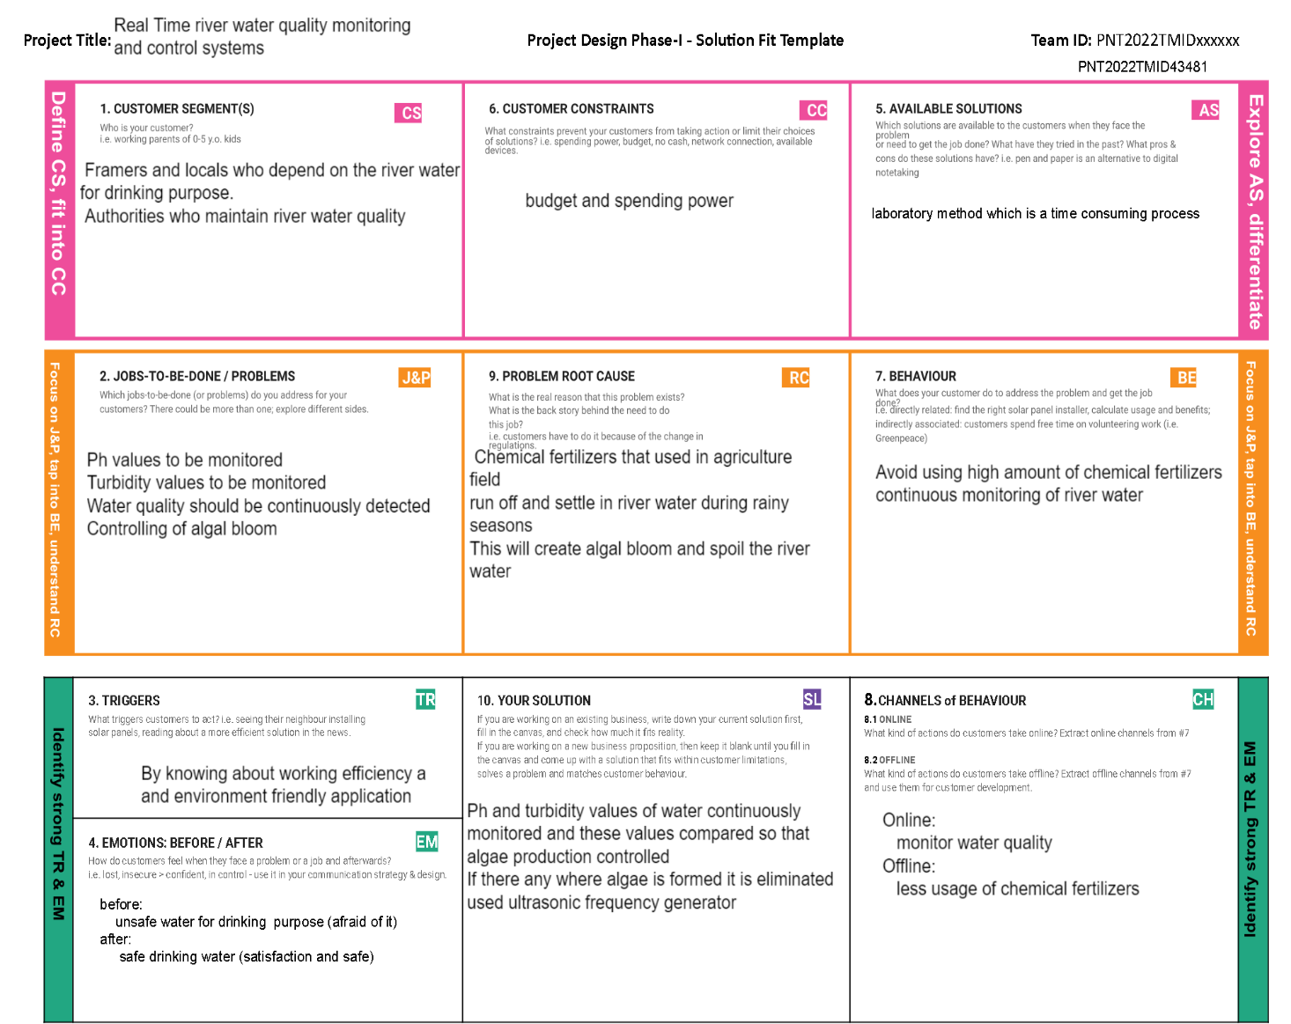

**REQUIREMENT ANALYSIS**

**FUNCTIONAL REQUIREMENTS**

|  |  |  |
| --- | --- | --- |
| **FR No.** | **Functional Requirement (Epic)** | **Sub Requirement (Story / Sub-Task)** |
| FR-1 | User Registration | Registration through Form  Registration through Gmail  Registration through product mobile UI |
| FR-2 | User Confirmation | Confirmation via Email Confirmation via  OTP |
| FR-3 | Ph level detection | Ph sensor is used to monitor the water quality and the signals are send to Arduino. |
| FR-4 | Turbidity detection | Turbidity sensor TS-300B measures the turbidity (counter of suspended matter) in the wash water and the signals are send to Arduino. |
| FR-5 | Ultrasonic generator | Waves generated at regular interval times to clear algae 25% ,50%, 100% |

**NON-FUNCTIONAL REQUIREMENTS**

|  |  |  |
| --- | --- | --- |
| **FR No.** | **Non-Functional Requirement** | **Description** |
| NFR-1 | **Usability** | Efficient to use and has simple monitoring system. |
| NFR-2 | **Security** | Mobile application is secured with firewalls protection. |
| NFR-3 | **Reliability** | Real time sensor output values with future predicted data storage. 98% efficient monitoring output. Assurance for aquaculture safety |
| NFR-4 | **Performance** | Greater performance and environmentally safe model. |
| NFR-5 | **Availability** | In form of mobile UI 24 x 7 monitoring system. |
| NFR-6 | **Scalability** | Highly Scalable. It is capable to produce a best final output. |
| NFR-7 | **Stability** | It is highly stable. |
| NFR-8 | **Efficiency** | It is highly efficient and it has simple monitoring system. |

**PROJECT DESIGN**

**DATA FLOW DIAGRAM**

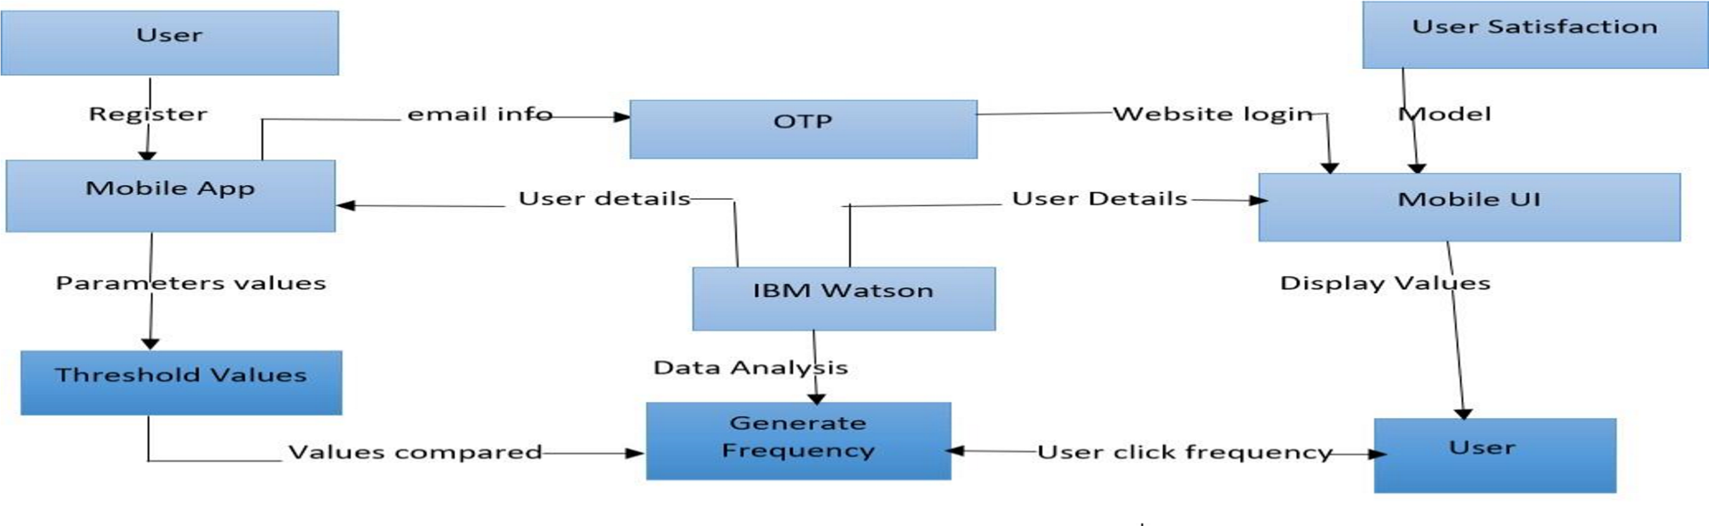

**SOLUTION AND TECHNICAL ARCHITECTURE**

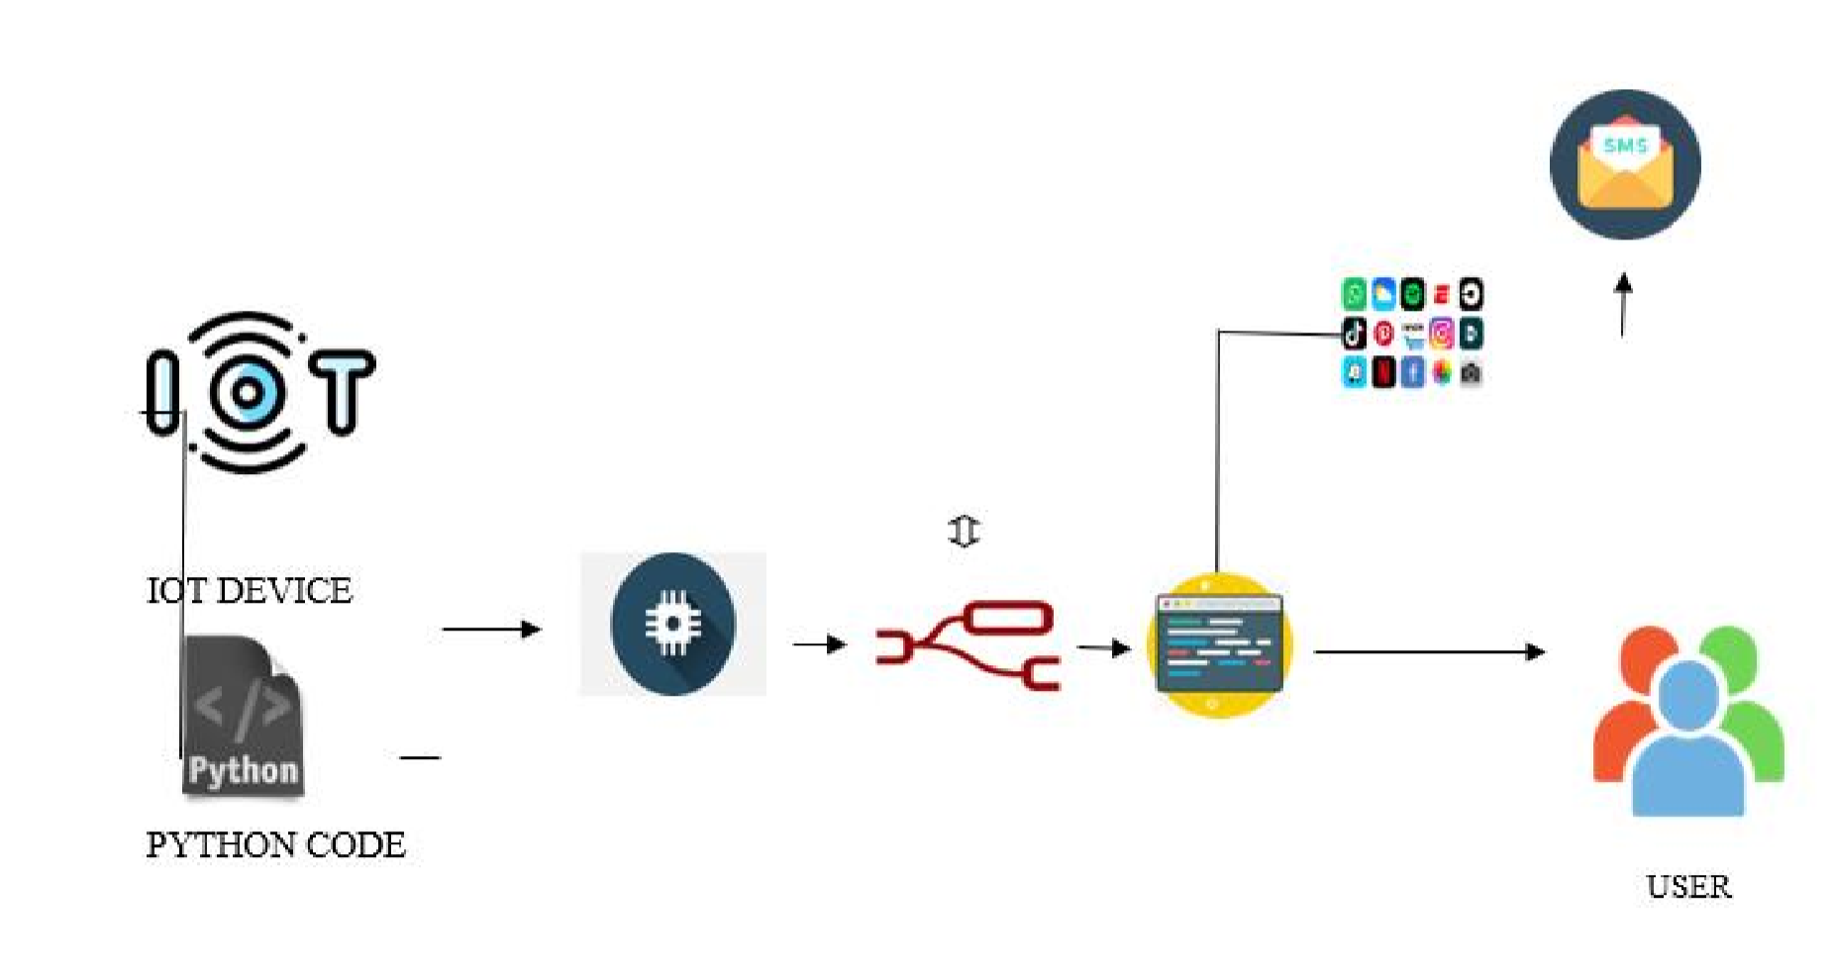

**USER STORIES**

|  |  |  |  |  |
| --- | --- | --- | --- | --- |
| **User Story Number** | **User Story / Task** | **Story Points** | **Priority** | **Team Members** |
| USN-1 | As a user, I can register for the | 2 | High | Vaishnavi R  Varunkumar  Thaila uma  Roshini  Narmatha |
|  | application by entering my email, |  |  |
|  | password, and confirming |  |  |
|  | my password. |  |  |
| USN-3 | As a user, I can register for the application through Facebook | 2 | Low |
| USN-4 | As a user, I can register for the application | 2 | Medium |
|  | through Gmail |  |  |
| USN-2 | As a user, I will receive confirmation email | 1 | High |
|  | once I have registered for the application |  |  |
| USN-5 | As a user, I can log into the application by | 1 | High |
|  | entering email & password |  |  |
|  | Get access to IBM cloud services. | 2 | High |

**PROJECT PLANNING AND SCHEDULING**

**SPRINT PLANNING AND ESTIMATION**

|  |  |  |  |  |  |  |
| --- | --- | --- | --- | --- | --- | --- |
| S.NO |  |  |  |  |  |  |
|  |  | ACTIVITY TITLE |  | ACTIVITY DESCRIPTION |  | DURATION |
| 1 |  | Understanding the project requirement |  | Assign the team members and create repository in the Github, Assign the task to each members and teach how to use and open and class the Github and IBM career education . |  | 1 WEEK |
| 2 |  | Starting of project |  | Advice students to attend classes of IBM portal create and develop an rough diagram |  |  |
|  |  |  |  | based on project description and gather of information on IOT and IBM project and team leader assign task to each member of the project . |  | 1 WEEK |
| 3 |  | Attend class |  | Team members and team lead must watch and learn from |  |  |
|  |  |  |  | classes provided by IBM and NALAYATHIRAN and must gain access of MIT license for their project. |  | 4 WEEK |
|
| 4 |  | Budget and scope of project |  | Budget and analyze the use of IOT in the project and discuss |  |  |
|  |  |  |  | with team for budget prediction to predict the favorability for the customer to buy |  | 1 WEEK |

**SPRINT DELIVERY SCHEDULE**

|  |  |  |  |  |  |  |
| --- | --- | --- | --- | --- | --- | --- |
| **Sprint** | **Total Story Points** | **Duration** | **Sprint Start Date** | **Sprint End Date (Planned)** | **Story Points Completed (as on Planned End Date)** | **Sprint Release Date (Actual)** |
| Sprint-1 | 20 | 2 Days | 24 Oct 2022 | 26 Oct 2022 | 20 | 29 Oct 2022 |
| Sprint-2 | 20 | 4 Days | 26 Oct 2022 | 30 Oct 2022 | 40 |  |
| Sprint-3 | 20 | 12 Days | 1 Nov 2022 | 12 Nov 2022 | 60 |  |
| Sprint-4 | 20 | 6 Days | 13 Nov 2022 | 19 Nov 2022 | 80 | 19 Nov 2022 |

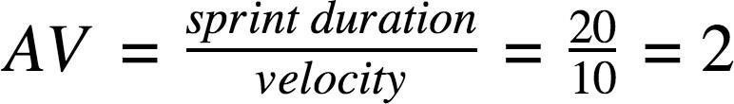

**Burndown Chart:**

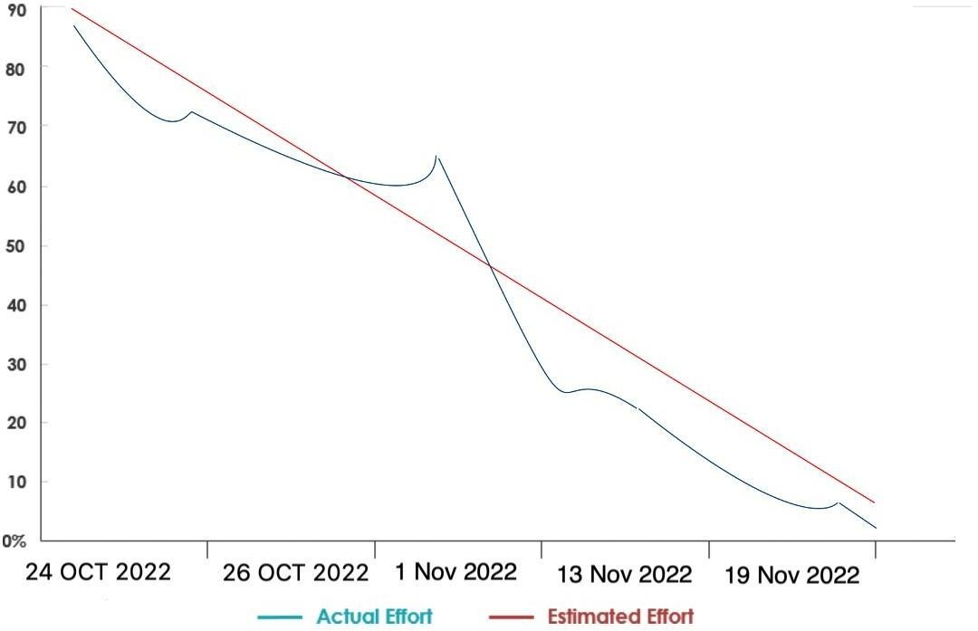

**REPORTS FROM JIRA**

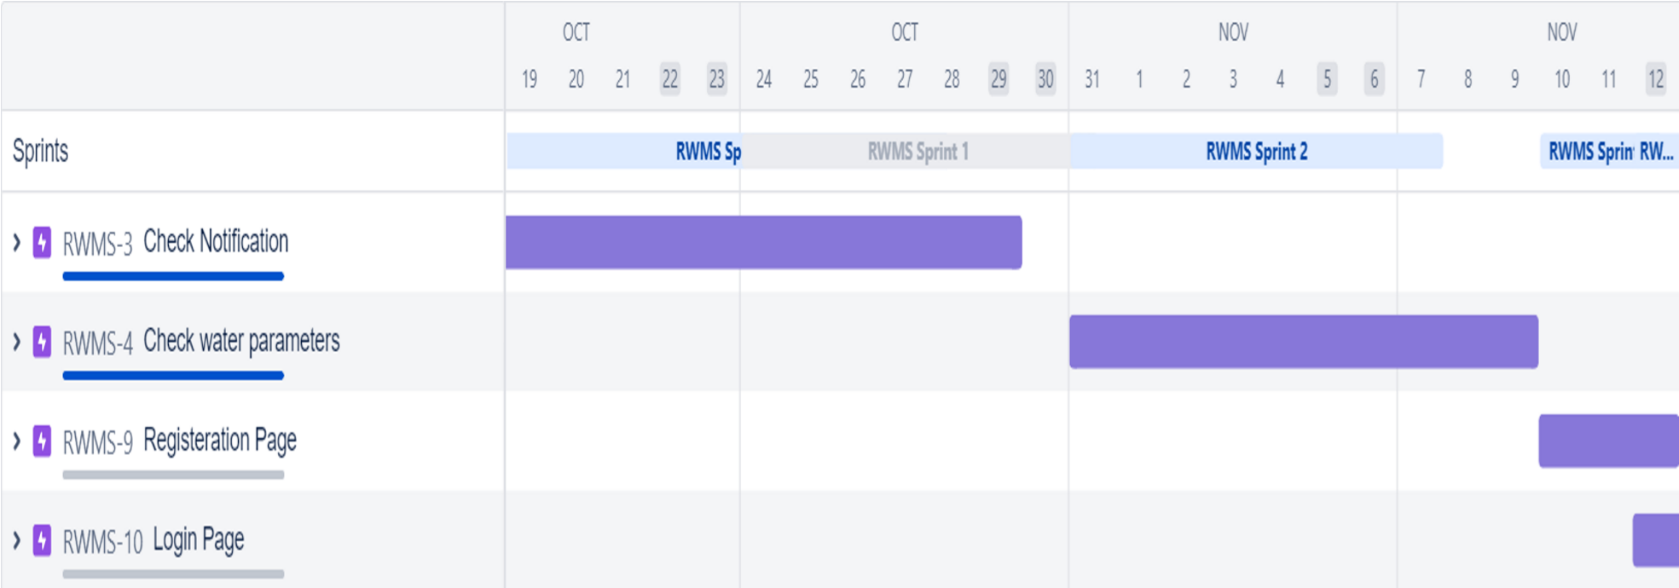

**CODING AND SOLUTIONING**

**NODE RED SERVICE ASSOCIATED WITH CLOUD**

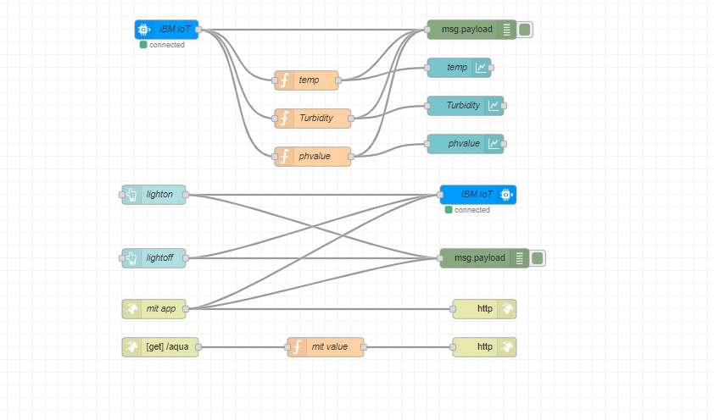

**OUTPUT**

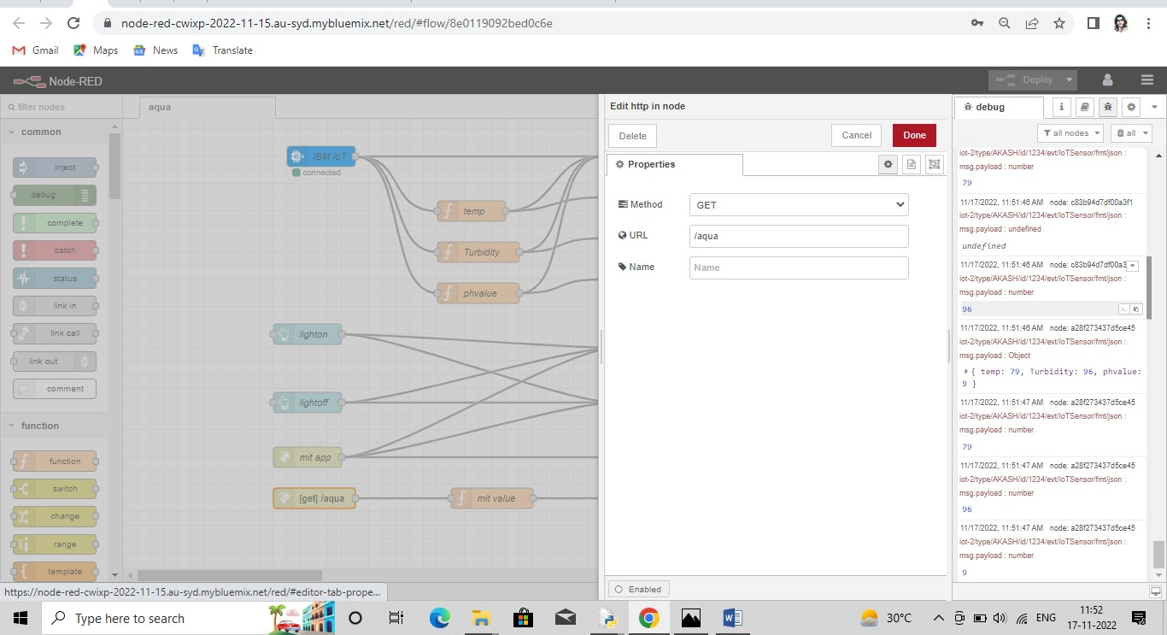

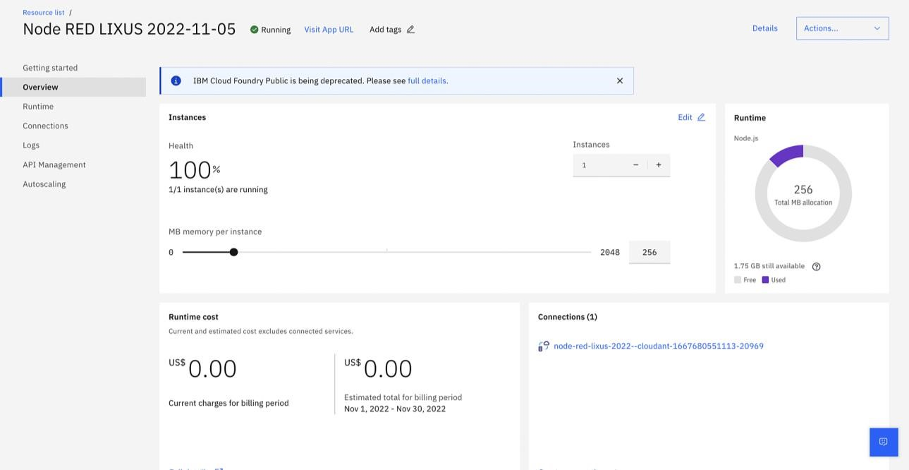

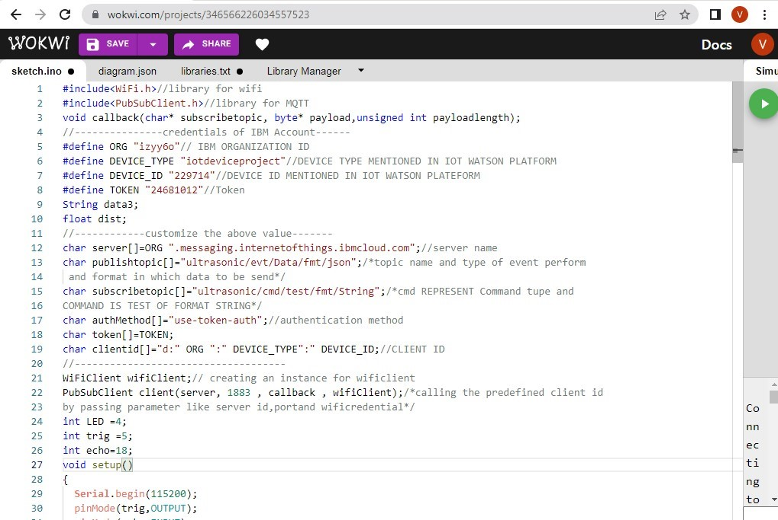

**TESTCASE ANALYSIS**

|  |  |  |  |  |
| --- | --- | --- | --- | --- |
| **Section** | **Total Cases** | **Not Tested** | **Fai l** | **Pass** |
| Print Engine | 15 | 0 | 0 | 15 |
| Client Application | 45 | 0 | 0 | 45 |
| Security | 1 | 0 | 0 | 1 |
| Outsource Shipping | 2 | 0 | 0 | 2 |
| Exception Reporting | 10 | 0 | 0 | 10 |
| Final Report Output | 4 | 0 | 0 | 4 |
| Version Control | 3 | 0 | 0 | 3 |

**USER ACCEPTANCE TESTING**

### Login:

* Verify user is able to see login page
* Verify user is able to loginto application or not?
* Verify login page elements

### Signup:

* Whether the user can signup or not
* The username and password entered are saved in database or not.

### View the water quality measures:

* Whether the user is able to see the pH,temperature and turbidity values.
* Wthether these values are periodically updated.

### SMS:

● Whether the user receives sms if water quality goes below a certain level

**RESULT**

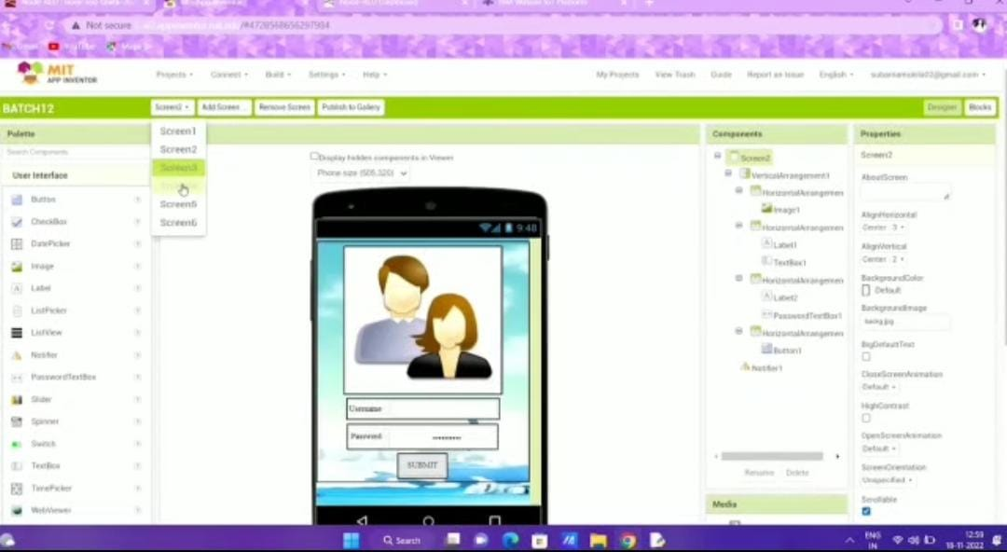

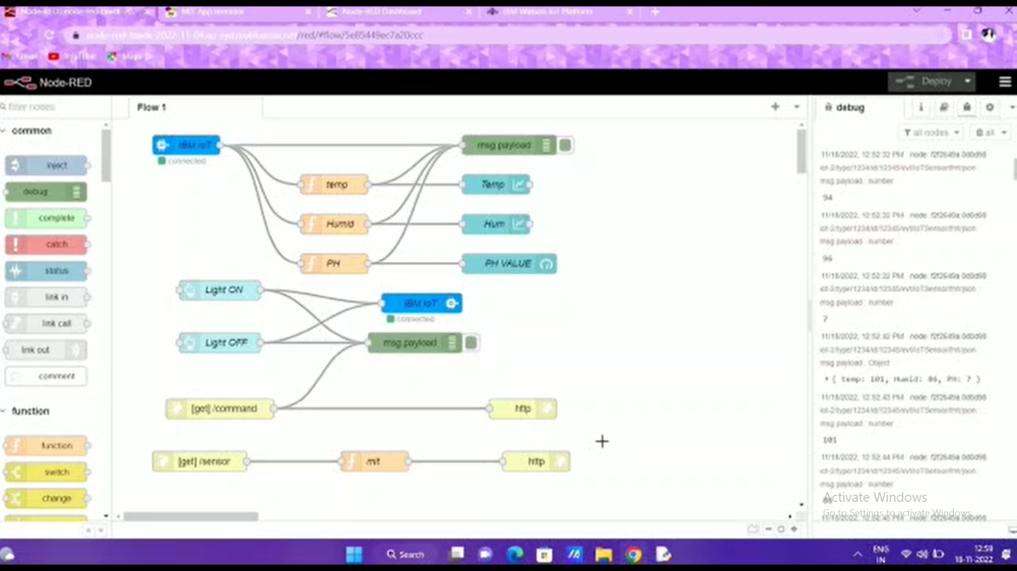

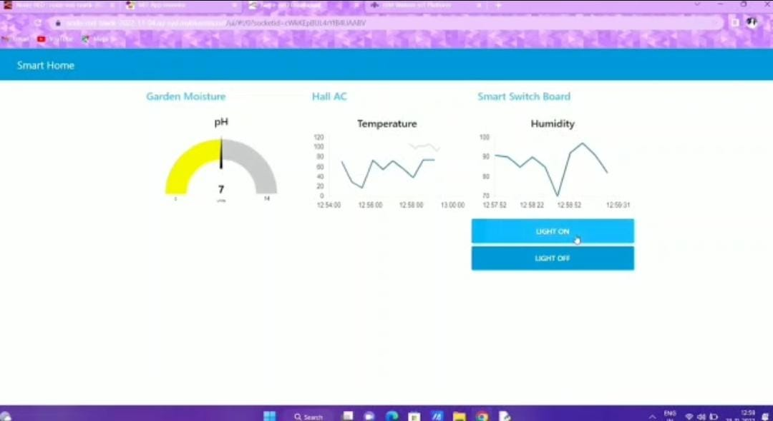

**ADVANTAGES**

* The prototype developed for water quality maintenance is very beneficial for safeguarding public health and also adds to the clean environment.
* The automation of this water monitoring, cleaning and control process removes the need of manual labor and thus saves time and money.
* The automation of the system makes the control and monitoring process more efficient and effective. Real time monitoring on mobile phone which is possible through the interface of plc with Arduino and Bluetooth module allows remote controlling of the system.

**DISADVANTAGES**

* It is difficult to collect the water samples from all the area of the water body.
* The cost of analysis is very high.
* The lab testing and analysis takes some time and hence the lab results does not reflect real time water quality measurement due to delay in measurement.
* The process is time consuming due to slow process of manual data collection from different locations of the water body.

**CONCLUSION**

Thus our project is used to Monitoring of humidity, PH & Temperature of Water makes use of water detection sensor with unique advantage and existing gsm network. The system can monitor water quality automatically, and it is low in cost and does not require people on duty. So the water quality testing is likely to be more economical, convenient and fast. The system has good flexibility. Only by replacing the corresponding sensors and changing the relevant software programs, this system can be used to monitor other water quality parameters.

The operation is simple. The system can be expanded to monitor hydrologic, air pollution, industrial and agricultural production and so on. It has widespread application and extension value.By keeping the embedded devices in the environment for monitoring enables self protection (i.e., smart environment) to the environment. To implement this need to deploy the sensor devices in the environment for collecting the data and analysis. By deploying sensor devices in the environment, we can bring the environment into real life i.e. it can interact with other objects through the network.

Then the collected data and analysis results will be available to the end user through the Wi-Fi.

**FUTURE SCOPE**

In future, we have planned to implement this project in large scale which will be helpful and used by all people. . We can also implement as a revenue model.This system could also be implemented in various industrial processes. The system can be modified according to the needs of the user and can be implemented along with lab view to monitor data on computers.

**APPENDIX**

**DEMO LINK :** [**https://drive.google.com/file/d/1u4m8h11ArcA9BfGBK3UzrT0CcUWS3sQk/view?usp=drivesdk**](https://drive.google.com/file/d/1u4m8h11ArcA9BfGBK3UzrT0CcUWS3sQk/view?usp=drivesdk)